Task Manager

# Add New Task Page:

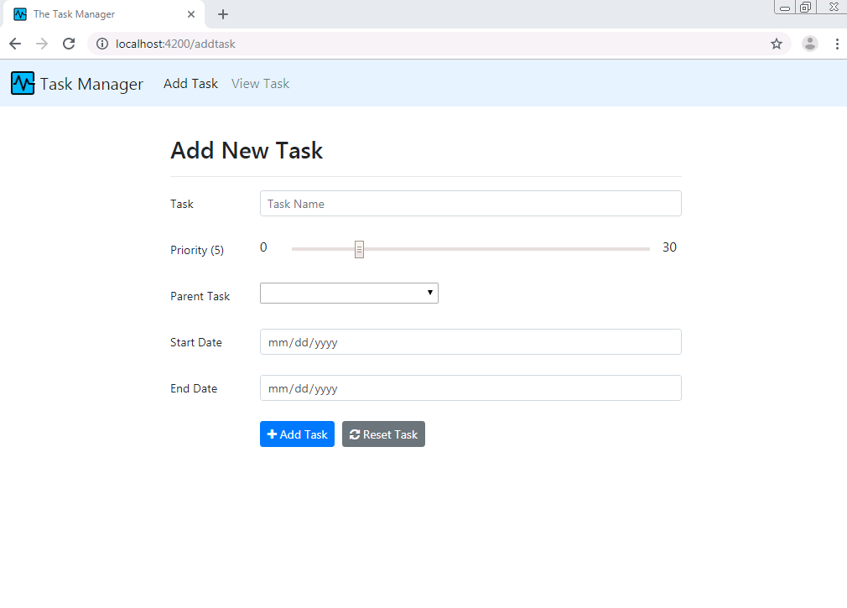

# View/Edit Task Page

# 

# Update Task Page

